Problem Statement:

asks To Be Performed:

Tasks To Be Performed: 1. Create an EFS and connect it to 3 different EC2 instances. Make sure that all instances have different operating systems. For instance, Ubuntu, Red Hat Linux and Amazon Linux 2.

Step 1:

Login to aws console

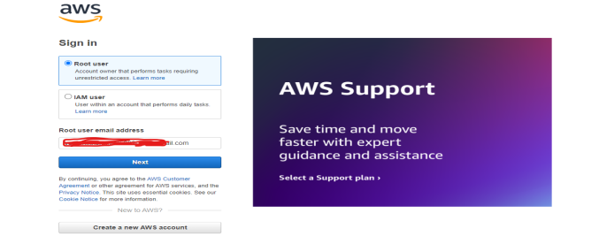

Step 2:

Search ec2 tool and select launch instence

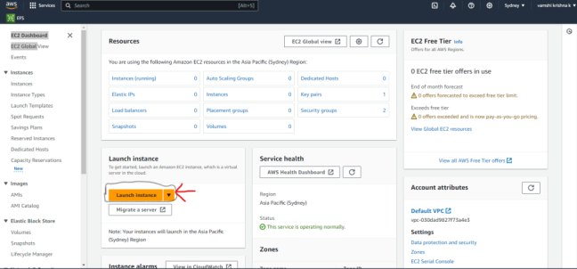

Step3:

Creat 3 instance: Name the instance ,select OS ,generate key pair ,select security group ,launch instance

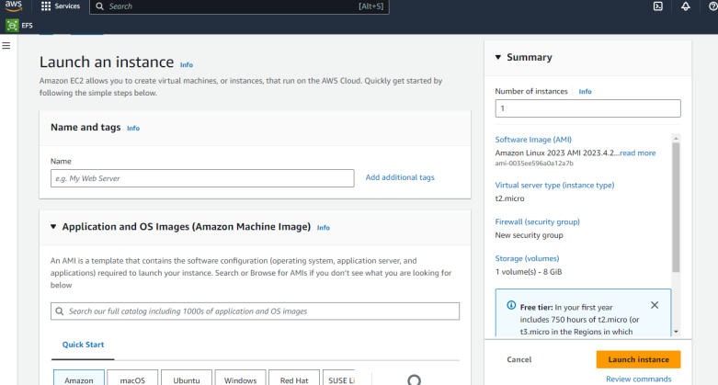

Step4:

3 Instance successfully created,with different os,with allowing the nfs in security group inbound rules

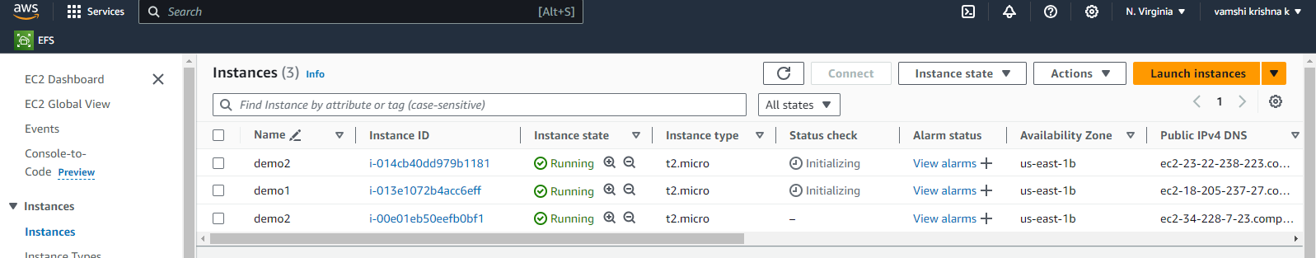

Step5:

Creat an efs and configure the security group as showm below in all az

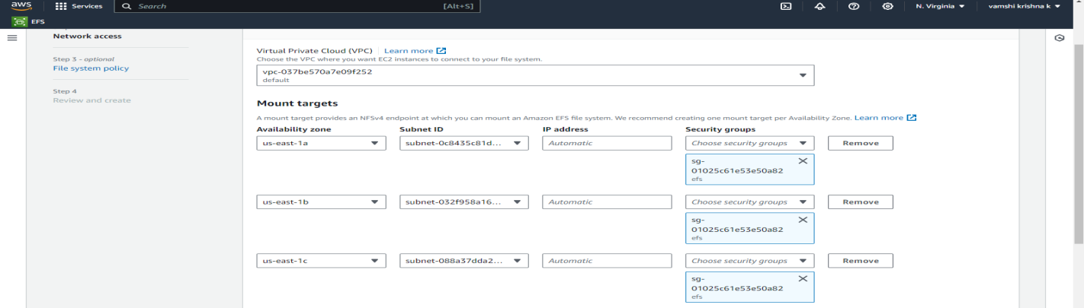

Step6: connect the instances and run the commands

For amazon linx:- 1)sudo yum update 2)sudo yum install nfs 3) sudo mkdir efs 5)mount the efs by copy pastimg the command in efs dashboard 5) sudo touch text.html 6)ls

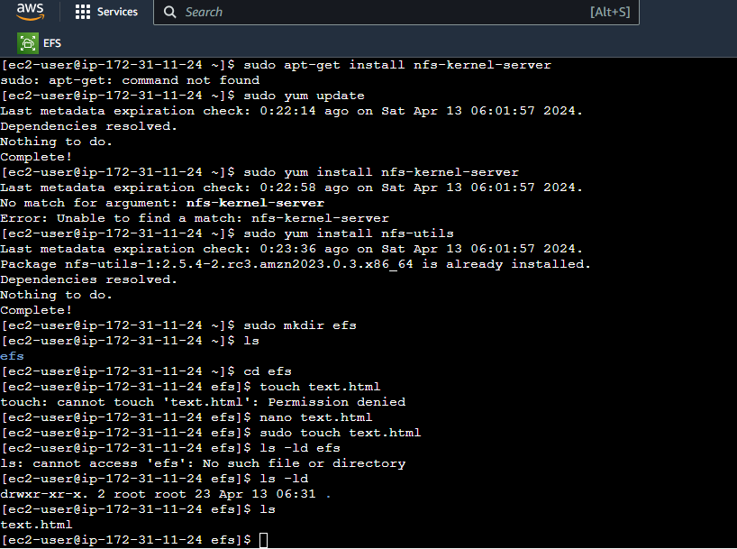

Step7: connect the other instance and run the command to install nfs and create a directory and mount the efs and use ls there we can see the file text.html that me created in 1st instance 